Muldoon Name ________________________________
Which obstacle was the most dangerous for Odysseus?
Directions: Write a paragraph answering the question above using at least TWO specific reasons from the text. Start with a TOPIC SENTENCE.
_____________________________________________________________________________________________
_____________________________________________________________________________________________
_____________________________________________________________________________________________
_____________________________________________________________________________________________
_____________________________________________________________________________________________
_____________________________________________________________________________________________
_____________________________________________________________________________________________
_______________________________________________________________________________________________________________________
_______________________________________________________________________________________________________________________
_______________________________________________________________________________________________________________________
_______________________________________________________________________________________________________________________
_______________________________________________________________________________________________________________________
_______________________________________________________________________________________________________________________
_______________________________________________________________________________________________________________________
_______________________________________________________________________________________________________________________
_______________________________________________________________________________________________________________________
_______________________________________________________________________________________________________________________
_______________________________________________________________________________________________________________________
Obstacles:
Cicones
Laestrygonians
Polyphemus
Zeus
Circe
Scylla
Charybdis
Sirens
Helios
_______________________________________________________________________________________________________________________
_______________________________________________________________________________________________________________________
_______________________________________________________________________________________________________________________
_______________________________________________________________________________________________________________________
_______________________________________________________________________________________________________________________
_______________________________________________________________________________________________________________________
_______________________________________________________________________________________________________________________
_______________________________________________________________________________________________________________________
_______________________________________________________________________________________________________________________
_______________________________________________________________________________________________________________________
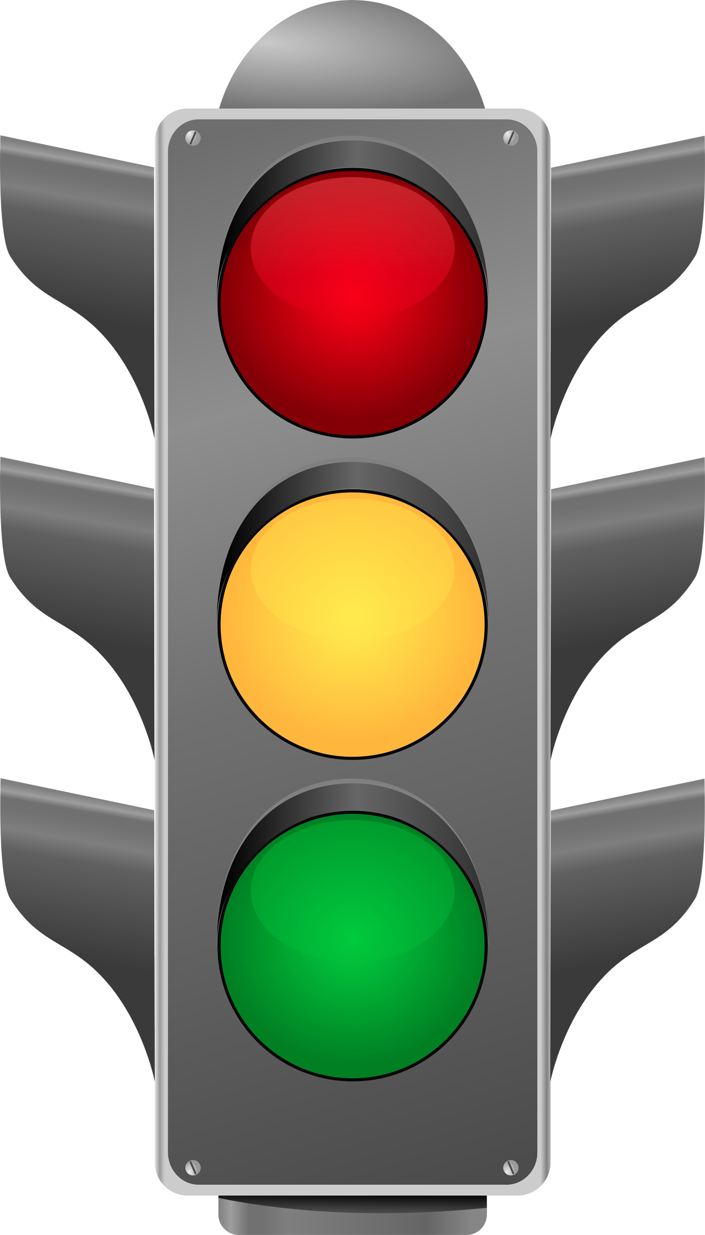
Muldoon Name ________________________________
Which obstacle was the most dangerous for Odysseus?
Directions: Write a paragraph answering the question above using at least TWO reasons. Use specific examples from the story to support your answer.
_______________________________________________________________________________________________________________________
_______________________________________________________________________________________________________________________
_______________________________________________________________________________________________________________________
_______________________________________________________________________________________________________________________
_______________________________________________________________________________________________________________________
_______________________________________________________________________________________________________________________
_______________________________________________________________________________________________________________________
_______________________________________________________________________________________________________________________
_______________________________________________________________________________________________________________________
_______________________________________________________________________________________________________________________
_______________________________________________________________________________________________________________________
Topic Sentence
Reason #1
Supporting Detail #1
Reason #2
Supporting Detail #2
Concluding Sentence
Obstacles:
Cicones
Laestrygonians
Polyphemus
Zeus
Circe
Scylla
Charybdis
Sirens
Helios
_______________________________________________________________________________________________________________________
_______________________________________________________________________________________________________________________
_______________________________________________________________________________________________________________________
_______________________________________________________________________________________________________________________
_______________________________________________________________________________________________________________________
_______________________________________________________________________________________________________________________
_______________________________________________________________________________________________________________________
_______________________________________________________________________________________________________________________
_______________________________________________________________________________________________________________________
_______________________________________________________________________________________________________________________
Muldoon Name ________________________________
Which obstacle was the most dangerous for Odysseus?
_______________________________________________________________________________________________________________________
_______________________________________________________________________________________________________________________
_______________________________________________________________________________________________________________________
_______________________________________________________________________________________________________________________
_______________________________________________________________________________________________________________________
_______________________________________________________________________________________________________________________
_______________________________________________________________________________________________________________________
_______________________________________________________________________________________________________________________
_______________________________________________________________________________________________________________________
_______________________________________________________________________________________________________________________
_______________________________________________________________________________________________________________________
_______________________________________________________________________________________________________________________
Topic Sentence
Key Idea #1
Supporting Detail #1
Key Idea #2
Supporting Detail #2
Concluding Sentence
Most dangerous obstacle:
First reason (Key Idea #1):
Second reason (Key Idea #2):
Obstacles:
Cicones
Laestrygonians
Polyphemus
Zeus
Circe
Scylla
Charybdis
Sirens
Helios

